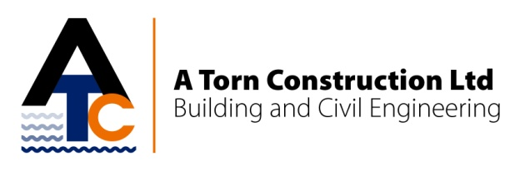

Graduate Engineer/Site Engineer

Attractive salary + bonus package - £neg

The ideal applicant should be qualified to at least HND/Degree level in Civil Engineering/Built Environment, with good Maths skills. Experience in setting out is essential along with Health and Safety knowledge and understanding of the construction process.

The role will be site based, working closely with the Project Manager and will include:

- Setting out
- Responsibility for labour, plant and materials
- Health and safety
- The role may then lead to:- tendering, client liaison and managing small projects.

A Torn Construction Ltd has wide experience in civils, building, marine, bridges and structures and places great emphasis on client satisfaction. We can offer real career progression for the right candidate, suiting individuals with initiative and self motivation – as the company grows so will you and your role.

Email your CV to mail@atornconstruction.co.uk, or post to:

A Torn Construction Ltd
Station Road
Kirton in Lindsey
Gainsborough
Lincolnshire
DN21 4BD

All applications should be received no later than 27th October 2014.

For more information about our company and other vacancies please visit our website at www.atornconstruction.co.uk

